Topics: Functions

A function is like a mini-program within a program.
To better understand how functions work, let’s create one. Type this program into the file editor and save it as helloFunc.py:

def hello():
print('Howdy!')
print('Howdy!!!') print('Hello there.')

hello() hello() hello()

The first line is a def statement, which defines a function named hello(). The code in the block that follows the def statement is the body of the function. This code is executed when the function is called, not when the function is first defined.

The hello() lines after the function are function calls. In code, a function call is just the function’s name followed by parentheses, possibly with some number of arguments in between the parentheses. When the program execution reaches these calls, it will jump to the top line in the function and begin executing the code there. When it reaches the end of the function, the execution returns to the line that called the function and continues moving through the code as before.

Since this program calls hello() three times, the code in the hello() function is executed three times. When you run this program, the output looks like this:

Howdy!
Howdy!!!
Hello there.
Howdy!
Howdy!!!
Hello there.
Howdy!
Howdy!!!
Hello there.

A major purpose of functions is to group code that gets executed mul- tiple times. Without a function defined, you would have to copy and paste this code each time, and the program would look like this:

print('Howdy!')

print('Howdy!!!') print('Hello there.') print('Howdy!')
print('Howdy!!!') print('Hello there.') print('Howdy!')
print('Howdy!!!') print('Hello there.')

def Statements with Parameters

When you call the print() or len() function, you pass in values, called arguments in this context, by typing them between the parentheses. You can also define your own functions that accept arguments.

def hello(name): print('Hello ' + name)

hello('Alice') hello('Bob')

When you run this program, the output looks like this:

Hello Alice Hello Bob

One special thing to note about parameters is that the value stored in a parameter is forgotten when the function returns. For example, if you added print(name) after hello('Bob') in the previous program, the program would give you a Name Error because there is no variable named name. This variable was destroyed after the function call hello('Bob') had returned, so print(name) would refer to a name variable that does not exist. This is similar to how a program’s variables are forgotten when the pro- gram terminates. I’ll talk more about why that happens later in the chapter, when I discuss what a function’s local scope is.

Return Values and return Statements

When you call the len() function and pass it an argument such as 'Hello', the function call evaluates to the integer value 5, which is the length of the string you passed it. In general, the value that a function call evaluates to is called the return value of the function.

When creating a function using the def statement, you can specify what the return value should be with a return statement. A return statement con- sists of the following:

  - The return keyword
  - The value or expression that the function should return

Type this code into the file editor and save it as magic8Ball.py:

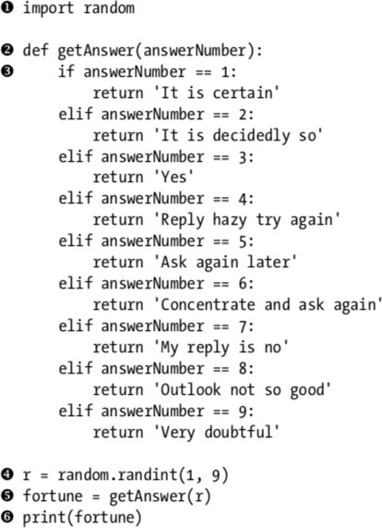

When this program starts, Python first imports the random module. Then the getAnswer() function is defined. Because the function is being defined (and not called), the execution skips over the code in it. Next, the random.randint() function is called with two arguments, 1 and 9 . It evalu- ates to a random integer between 1 and 9 (including 1 and 9 themselves), and this value is stored in a variable named r.

The getAnswer() function is called with r as the argument. The pro- gram execution moves to the top of the getAnswer() function, and the value r is stored in a parameter named answerNumber. Then, depending on this value in answerNumber, the function returns one of many possible string values. The program execution returns to the line at the bottom of the pro- gram that originally called getAnswer(). The returned string is assigned to a variable named fortune, which then gets passed to a print() call and is printed to the screen.

Note that since you can pass return values as an argument to another function call, you could shorten these three lines:
r = random.randint(1, 9) fortune = getAnswer(r)

print(fortune)

to this single equivalent line: print(getAnswer(random.randint(1, 9)))

Remember, expressions are composed of values and operators. A func- tion call can be used in an expression because it evaluates to its return value.

The none Value

In Python there is a value called None, which represents the absence of a value. None is the only value of the NoneType data type. (Other programming languages might call this value null, nil, or undefined.) Just like the Boolean True and False values, None must be typed with a capital N.

The print() function displays text on the screen, but it doesn’t need to return anything in the same way len() or input() does. But since all function calls need to evaluate to a return value, print() returns None. To see this in action, enter the following into the interactive shell:

>>> spam = print('Hello!') Hello!
>>> None == spam True

Behind the scenes, Python adds return None to the end of any func- tion definition with no return statement. This is similar to how a while or for loop implicitly ends with a continue statement. Also, if you use a return state- ment without a value (that is, just the return keyword by itself), then None is returned.

keyword Arguments and print()

keyword arguments are identified by the keyword put before them in the function call. Keyword arguments are often used for optional parameters. For example, the print() function has the optional parameters end and sep to specify what should be printed at the end of its arguments and between its arguments (separating them), respectively.

E.g.
print('Hello') print('World')

Output:

Hello World

The two strings appear on separate lines because the print() function automatically adds a newline character to the end of the string it is passed. However, you can set the end keyword argument to change this to a different string. For example, if the program were this:

print('Hello', end='') print('World')

output:

HelloWorld

when you pass multiple string values to print(), the function will automatically separate them with a single space. Enter the following into the interactive shell:

>>> print('cats', 'dogs', 'mice')

cats dogs mice

But you could replace the default separating string by passing the sep keyword argument. Enter the following into the interactive shell:

>>> print('cats', 'dogs', 'mice', sep=',')

cats,dogs,mice

local and global Scope

Parameters and variables that are assigned in a called function are said to exist in that function’s local scope. Variables that are assigned outside all functions are said to exist in the global scope. A variable that exists in a local scope is called a local variable, while a variable that exists in the global scope is called a global variable. A variable must be one or the other; it cannot be both local and global.

A local scope is created whenever a function is called. Any variables assigned in this function exist within the local scope. When the function returns, the local scope is destroyed, and these variables are forgotten. The next time you call this function, the local variables will not remember the values stored in them from the last time the function was called.

Scopes matter for several reasons:

- Code in the global scope cannot use any local variables.
- However, a local scope can access global variables.
- Code in a function’s local scope cannot use variables in any other local scope.
- You can use the same name for different variables if they are in dif- ferent scopes. That is, there can be a local variable named spam and a global variable also named spam.

The reason Python has different scopes instead of just making every- thing a global variable is so that when variables are modified by the code in a particular call to a function, the function interacts with the rest of the program only through its parameters and the return value. This nar- rows down the list code lines that may be causing a bug. If your program contained nothing but global variables and had a bug because of a variable being set to a bad value, then it would be hard to track down where this bad value was set. It could have been set from anywhere in the program—and your program could be hundreds or thousands of lines long! But if the bug is because of a local variable with a bad value, you know that only the code in that one function could have set it incorrectly.

While using global variables in small programs is fine, it is a bad habit to rely on global variables as your programs get larger and larger.

1. Local Variables Cannot Be Used in the Global Scope
Consider this program, which will cause an error when you run it: def spam():
eggs = 31337 spam() print(eggs)

If you run this program, the output will look like this: Traceback (most recent call last):
File "C:/test3784.py", line 4, in <module> print(eggs)
NameError: name 'eggs' is not defined

The error happens because the eggs variable exists only in the local scope created when spam() is called. Once the program execution returns from spam, that local scope is destroyed, and there is no longer a variable named eggs. So when your program tries to run print(eggs), Python gives you an error saying that eggs is not defined. This makes sense if you think about it; when the program execution is in the global scope, no local scopes exist, so there can’t be any local variables. This is why only global variables can be used in the global scope.

Local Scopes Cannot Use Variables in Other Local Scopes

A new local scope is created whenever a function is called, including when a function is called from another function. Consider this program:
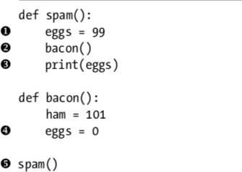

When the program starts, the spam() function is called, and a local scope is created. The local variable eggs is set to 99. Then the bacon() function is called , and a second local scope is created. Multiple local scopes can exist at the same time. In this new local scope, the local variable ham is set to 101, and a local variable eggs—which is different from the one in spam()’s local scope—is also created and set to 0.

When bacon() returns, the local scope for that call is destroyed. The pro- gram execution continues in the spam() function to print the value of eggs , and since the local scope for the call to spam() still exists here, the eggs vari- able is set to 99. This is what the program prints.

The upshot is that local variables in one function are completely sepa- rate from the local variables in another function.

Global Variables Can Be Read from a Local Scope

Consider the following program:

def spam():
print(eggs) eggs = 42 spam() print(eggs)

Since there is no parameter named eggs or any code that assigns eggs a value in the spam() function, when eggs is used in spam(), Python considers it a reference to the global variable eggs. This is why 42 is printed when the previous program is run.

Local and Global Variables with the Same Name

To simplify your life, avoid using local variables that have the same name as a global variable or another local variable. But technically, it’s perfectly legal to do so in Python. To see what happens, type the following code into the file editor and save it as sameName.py:

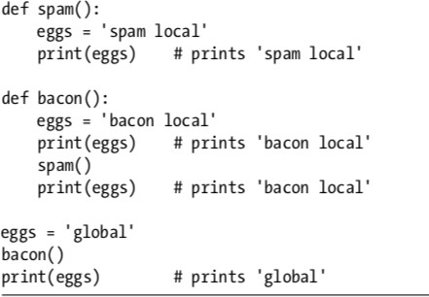

When you run this program, it outputs the following:

bacon local spam local bacon local global

There are actually three different variables in this program, but confus- ingly they are all named eggs. The variables are as follows:

- A variable named eggs that exists in a local scope when spam() is called.
- A variable named eggs that exists in a local scope when bacon() is called.
- A variable named eggs that exists in the global scope.

Since these three separate variables all have the same name, it can be confusing to keep track of which one is being used at any given time. This is why you should avoid using the same variable name in different scopes.

The global Statement

If you need to modify a global variable from within a function, use the global statement. If you have a line such as global eggs at the top of a function,
it tells Python, “In this function, eggs refers to the global variable, so don’t create a local variable with
this name.” For example, type the following code into the file editor and save it as sameName2.py:

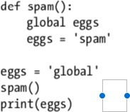

When you run this program, the final print() call will output this:

spam

Because eggs is declared global at the top of spam()u, when eggs is set to 'spam'v, this assignment is done to the globally scoped spam. No local spam variable is created.

There are four rules to tell whether a variable is in a local scope or global scope:

- If a variable is being used in the global scope (that is, outside of all functions), then it is always a global variable.
- If there is a global statement for that variable in a function, it is a global variable.
- Otherwise, if the variable is used in an assignment statement in the function, it is a local variable.
- But if the variable is not used in an assignment statement, it is a global variable

To get a better feel for these rules, here’s an example program. Type the following code into the file editor and save it as sameName3.py:

def spam():
global eggs
eggs = 'spam' # this is the global def bacon():
eggs = 'bacon' # this is a local def ham():
print(eggs) # this is the global

eggs = 42 # this is the global spam()
print(eggs)

In the spam() function, eggs is the global eggs variable, because there’s a global statement for eggs at the beginning of the functionu. In bacon(), eggs is a local variable, because there’s an assignment statement for it in that functionv. In ham()w, eggs is the global variable, because there is no assignment statement or global statement for it in that function. If you run sameName3.py, the output will look like this:

spam

In a function, a variable will either always be global or always be local. There’s no way that the code in a function can use a local variable named eggs and then later in that same function use the global eggs variable.

Note : If you ever want to modify the value stored in a global variable from in a function, you must use a global statement on that variable.

If you try to use a local variable in a function before you assign a value to it, as in the following program, Python will give you an error. To see this, type the following into the file editor and save it as sameName4.py:

def spam():
print(eggs) # ERROR! eggs = 'spam local'
eggs = 'global' spam()

If you run the previous program, it produces an error message. Traceback (most recent call last):
File "C:/test3784.py", line 6, in <module> spam()
File "C:/test3784.py", line 2, in spam print(eggs) # ERROR!
UnboundLocalError: local variable 'eggs' referenced before assignment

This error happens because Python sees that there is an assignment statement for eggs in the spam() function and therefore considers eggs to be local. But because print(eggs) is executed before eggs is assigned any- thing, the local variable eggs doesn’t exist. Python will not fall back to using the global eggs variable.

exception handling

getting an error, or exception, in your Python program means the entire program will crash. You don’t want this to happen in real-world pro- grams. Instead, you want the program to detect errors, handle them, and then continue to run.
For example, consider the following program, which has a “divide-by- zero” error. Open a new
file editor window and enter the following code, saving it as zeroDivide.py:

def spam(divideBy):
return 42 / divideBy print(spam(2))

print(spam(12)) print(spam(0))
print(spam(1))

We’ve defined a function called spam, given it a parameter, and then printed the value of that function with various parameters to see what hap- pens. This is the output you get when you run the previous code:
21.0
3.5
Traceback (most recent call last):
File "C:/zeroDivide.py", line 6, in <module> print(spam(0))
File "C:/zeroDivide.py", line 2, in spam return 42 / divideBy
ZeroDivisionError: division by zero

A ZeroDivisionError happens whenever you try to divide a number by zero. From the line number given in the error message, you know that the return statement in spam() is causing an error.
Errors can be handled with try and except statements. The code that could potentially have an error is put in a try clause. The program execu- tion moves to the start of a following except clause if an error happens.
You can put the previous divide-by-zero code in a try clause and have an except clause contain code to handle what happens when this error occurs.

def spam(divideBy): try:
return 42 / divideBy except ZeroDivisionError:
print('Error: Invalid argument.')

print(spam(2)) print(spam(12)) print(spam(0)) print(spam(1))

When code in a try clause causes an error, the program execution immediately moves to the code in the except clause. After running that code, the execution continues as normal. The output of the previous pro- gram is as follows:

21.0
3.5
Error: Invalid argument. None
42.0

Note that any errors that occur in function calls in a try block will also be caught. Consider the following program, which instead has the spam() calls in the try block:

def spam(divideBy): return 42 / divideBy
try:
print(spam(2)) print(spam(12)) print(spam(0)) print(spam(1))
except ZeroDivisionError: print('Error: Invalid argument.')

When this program is run, the output looks like this:

21.0
3.5
Error: Invalid argument.

The reason print(spam(1)) is never executed is because once the execu- tion jumps to the code in the except clause, it does not return to the try clause. Instead, it just continues moving down as normal.

A Short Program: guess the number

Type the following source code into the file editor, and save the file as guessTheNumber.py:

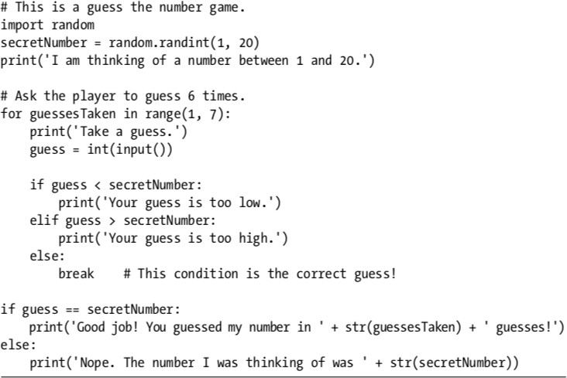

Explanation :
Let’s look at this code line by line, starting at the top. # This is a guess the number game.
import random
secretNumber = random.randint(1, 20)

First, a comment at the top of the code explains what the program does. Then, the program imports the random module so that it can use the random.randint() function to generate a number for the user to guess. The return value, a random integer between 1 and 20, is stored in the variable secretNumber.

print('I am thinking of a number between 1 and 20.') # Ask the player to guess 6 times.
for guessesTaken in range(1, 7): print('Take a guess.') guess = int(input())

The program tells the player that it has come up with a secret number and will give the player six chances to guess it. The code that lets the player enter a guess and checks that guess is in a for loop that will loop at most six times. The first thing that happens in the loop is that the player types in a guess. Since input() returns a string, its return value is passed straight into int(), which translates the string into an integer value. This gets stored in a variable named guess.

if guess < secretNumber: print('Your guess is too low.')
elif guess > secretNumber: print('Your guess is too high.')

These few lines of code check to see whether the guess is less than or greater than the secret number. In either case, a hint is printed to the screen.

else:
break # This condition is the correct guess!

If the guess is neither higher nor lower than the secret number, then it must be equal to the secret number, in which case you want the program execution to break out of the for loop.

if guess == secretNumber:
print('Good job! You guessed my number in ' + str(guessesTaken) + ' guesses!') else:
print('Nope. The number I was thinking of was ' + str(secretNumber))

After the for loop, the previous if...else statement checks whether the player has correctly guessed the number and prints an appropriate message to the screen. In both cases, the program displays a variable that contains

an integer value (guessesTaken and secretNumber). Since it must concatenate these integer values to strings, it passes these variables to the str() function, which returns the string value form of these integers. Now these strings can be concatenated with the + operators before finally being passed to the print() function call.

Output of above program will be:

I am thinking of a number between 1 and 20. Take a guess.

10
Your guess is too low. Take a guess.

15
Your guess is too low. Take a guess.

17
Your guess is too high.
Take a guess.

16
Good job! You guessed my number in 4 guesses!

